|  |  |  |  |  |
| --- | --- | --- | --- | --- |
| **Monday** | **Tuesday** | **Wednesday** | **Thursday** | **Friday** |
|  | 8  Write about your first day of school. | 9  Write about your favorite food to someone who never saw or tasted it. | 10  Write a letter to the teacher to introduce yourself. | 11  Write about what you are looking forward to this year. |
| 14  What makes a good friend? | 15  Describe one time when you were brave. | 16  Why is learning Important? | 17  Write 5 questions you want to ask your teacher or principal. | 18  What do you like best about summer? |
| 21  If you could have any animal for a pet, what would it be? Describe the pet and how you would take care of it. | 22  Write a story about a fall day. | 23  If you could spend the day with someone, who would it be? What would you do? | 24  Should students wear uniforms? Why or Why not? | 25  What will you miss about summer? |
| 28  Write about something you are good at. | 29  FREE | 30  Write a story with this title: Meet My Family | 26  Should teachers give homework? Why or why not? | 27  Write a paragraph that describes what you look like. |

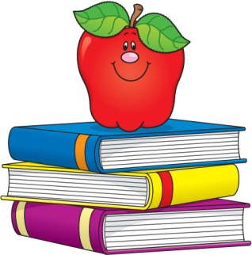**September Journal Activities**